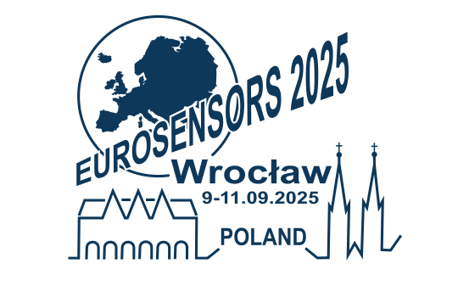

**OFFICIAL INVITATION LETTER**

__________________________________________________________________________

## 37th European Conference on Solid-State Transducers Eurosensors 2025 will be held from 7th till 10th of September in Wroclaw at the Poland Wroclaw University of Science & Technology

On behalf of the Organizers – the Faculty of Electronics, Photonics and Microsystems of the Wrocław University of Science and Technology - we are delighted to formally invite:

Family name:

First Name:

Date of birth :

Country of residence:

Nationality:

Passport No:

Date of Issue:

Valid of Expiry:

Issued by:

Place of employment:

We confirm that above participant has duly registered for the37th European Conference on Solid-State Transducers Eurosensors 2025 and has paid registration fee.

The participant is responsible for planning the stay in Wroclaw, as well as paying on his own for flights and accommodation, and also to deal with other costs that may occur (e.g. additional costs of different means of transport, health certificate that may be needed due to pandemic or other circumstances).

For any further information please visit the congress website <https://eurosensors2025.symposium.pl/> or contact the Conference Organiser:

SYMPOSIUM CRACOVIENSE

ul. Rakowicka 1/14, 31-511 Kraków, Poland

Phone: +48 12 422 76 00

email: [agnieszka.bryk@symposium.pl](mailto:agnieszka.bryk@symposium.pl)